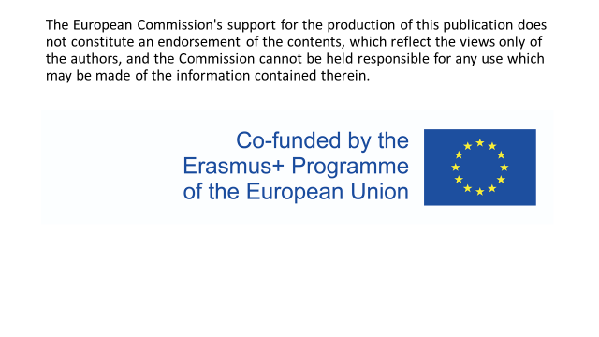Questionnaire for teachers
All questions refer only to students who study nursing fields

Country: The Czech Republic

Number of students who study nursing fields:
- 264 students study PRACTICAL NURSE, everyday a four- year course, age of students 15 -19.
- 65 students study REGISTERED NURSE, everyday a three-year course, age of students is over 20

How many students with different nationalities study nursing fields?
Out of 264 students studying daily Practical Nurse 3 students are of a different nationality. They are Ukrainians.
Out of 65 students studying Registered Nurse 3 are Ukrainians.

How do you deal with language barriers?
Ukrainians arrived in spring and summer 2022 without any knowledge of Czech. They passed the exam to enter our school in Russian. In September we had a great difficulty to communicate to them. Even though they have extra Czech lessons, they still do not understand properly and they are not able to speak. It creates a problem especially during practical training. Some of them suffer from depression and need a psychological help.

How do you deal with culture differences and mutual prejudice?
Although we do not have students with different nationalities that much, we sometimes have a foreign student for a year as a part of international projects. These students came from Brazil or the USA. We also enable foreign students a short term hospital training. These students come from Poland, Turkey, Spain and Germany. We always discuss cultural differences with our students beforehand to make sure there is not any misunderstanding.
As far as students from Ukraine, our students are in most cases sympathetic to them.

Do you have any students with physical disabilities? How many? Specify disabilities. How do you help them?
We do not have any students with physical disabilities since it is a necessary requirement for being admitted to study PRACTICAL NURSE.

Do you have any students with learning disorders?[dyslexia, dyscalculia…]? How many? How do you help them?
Out of the 264 students studying PRACTICAL NURSE 23 have some learning disorders.
Types of disorders:
- Dyslexia, dysorthographia – 8 students
- Dyslexia, dysorthographia, dysgraphia – 2 student
- Dysorthographia – 2 student
- Dysgraphia - 2 student
- Dyslexia, dysgraphia – 2 student
- Poor ability to concentrate – 1 student
- Dysgraphia, disorder of motor-visual coordination – 1 student
- Dyslexia, anxiety – 1 student
- Dyscalculia - 2 students
- Expressive dysphasia, ADHD, dyslexia, dysorthographia – 1 student
- Dyslexia, dysorthographia, poor concentration – 1 student
There is a counselor at each school in the Czech Republic who helps students with these disorders. Moreover they all need to have a medical opinion. On the basis of the medical report teachers are obliged to adjust their demands. Even the state final exam at the end of their studies is modified accordingly.
Do you have any behavioral problems at school? What sort of problems? [drugs, smoking, truancy, bullying…] How do you deal with it?
The most common problem is smoking. It is strictly forbidden on all school premises. Nevertheless, students sometimes tend to break the rule and smoke somewhere near the school. They are punished and offered a course how to quit smoking.
The teachers can use alcohol testers if they have suspicion that a student is under the influence of alcohol.
If there is a suspicion of bullying at school, we always cooperate with the school psychologist and the police.
In our school there is a person responsible for prevention of drug usage, smoking and inappropriate behavior. She organizes a variety of preventive activities. Also the school psychologist is employed here.

